You WILL PRACTICE TYPING WITH THE FOLLOWING FINGERS:

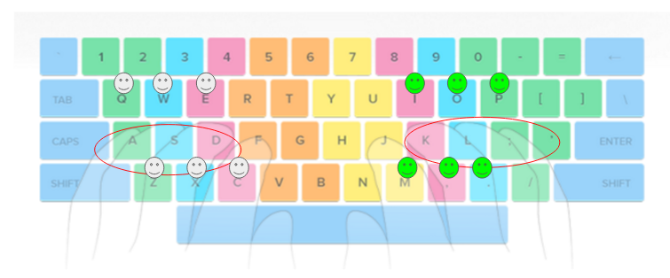

When you finish, copy and paste how you did for each one and TURN IN:

|  |  |
| --- | --- |
| [Typing Practice 12: Home Row Review 1](http://typingtestnow.com/app/keyboarding_online/12.html)  TIME 00:13  ACCURACY: 49%  ERRORS: 38  [Typing Practice 13: Home Row Review 2](http://typingtestnow.com/app/keyboarding_online/13.html) TIME 00:17  ACCURACY: 98%  ERRORS: 1  [Typing Practice 14: Home Row Review 3](http://typingtestnow.com/app/keyboarding_online/14.html)  [Typing Practice 15: Home Row Review 4](http://typingtestnow.com/app/keyboarding_online/15.html)  [Typing Practice 16: Home Row Review 5](http://typingtestnow.com/app/keyboarding_online/16.html)  [Typing Practice 17: Home Row Review 6](http://typingtestnow.com/app/keyboarding_online/17.html)  [Typing Practice 18: Top Row - Index fingers: R and U](http://typingtestnow.com/app/keyboarding_online/18.html)  [Typing Practice 19: Top Row - Middle fingers: E and I](http://typingtestnow.com/app/keyboarding_online/19.html)  [Typing Practice 20: Top Row - Ring fingers: W and O](http://typingtestnow.com/app/keyboarding_online/20.html)  [Typing Practice 21: Top Row - Pinkie fingers: Q and P](http://typingtestnow.com/app/keyboarding_online/21.html)  [Typing Practice 22: Top Row - Index fingers: T and Y](http://typingtestnow.com/app/keyboarding_online/22.html) |  |